Cs3307 Quiz: OO Concepts, Analysis, and Models

1.

i)[D1-design]

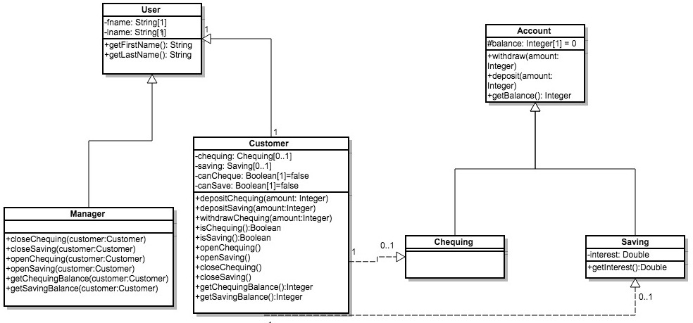

ii)[D2 – class reference in code]

|  |  |
| --- | --- |
| Class Name | Reference In Program |
| User | User.cpp line 6 |
| Manager | users.cpp |
|  |  |